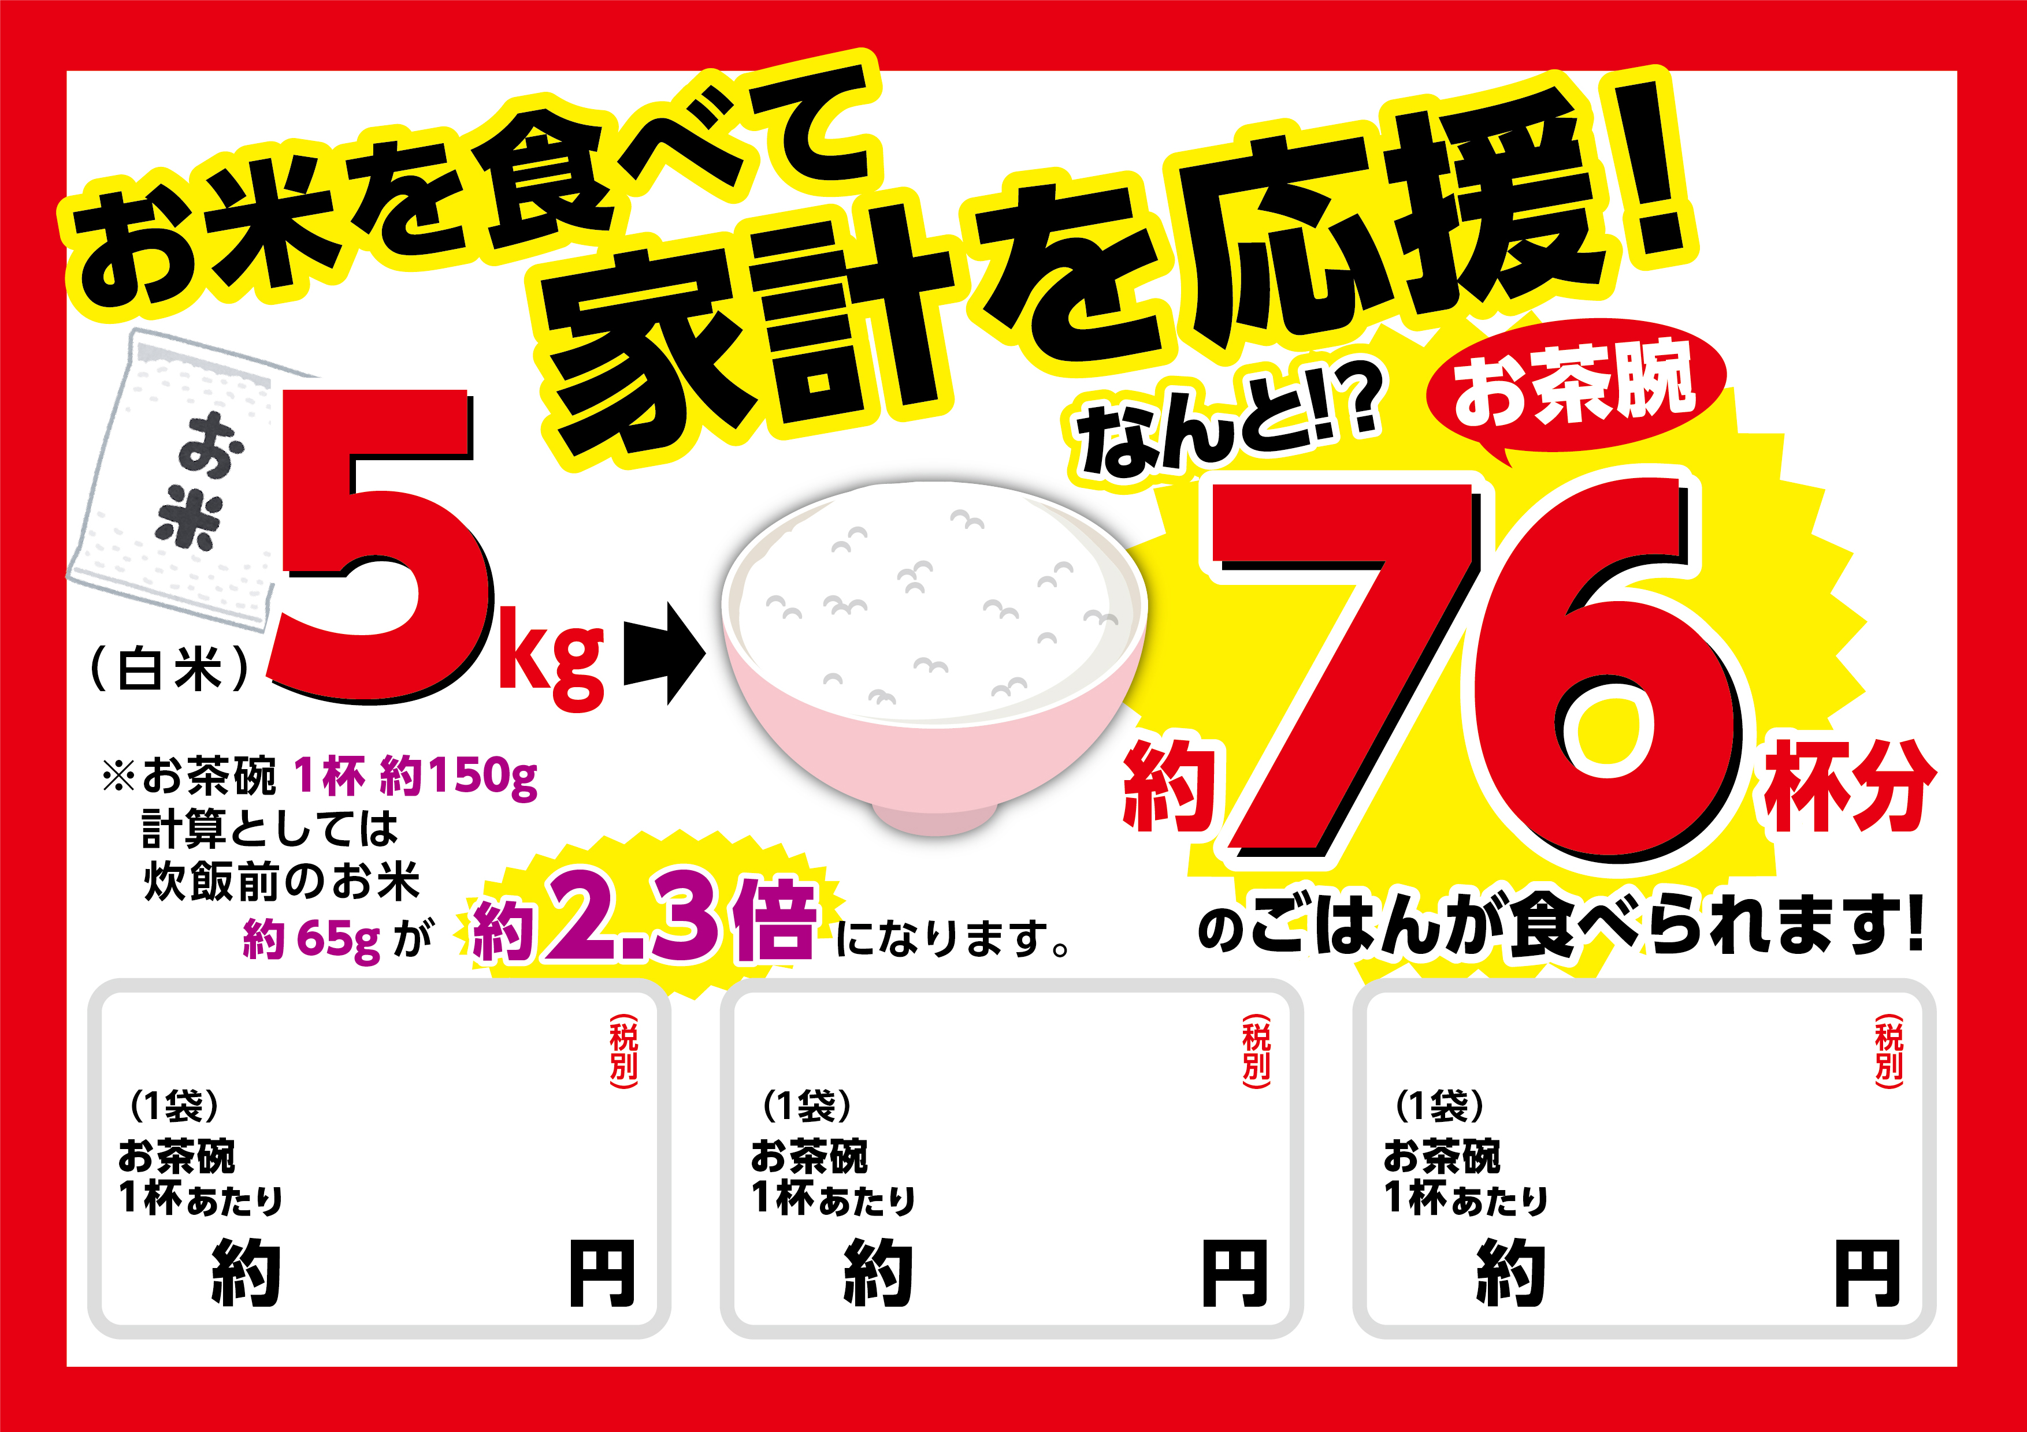
50
5kg
\3,780
48
5kg
\3,580
53
5kg
\3,980

