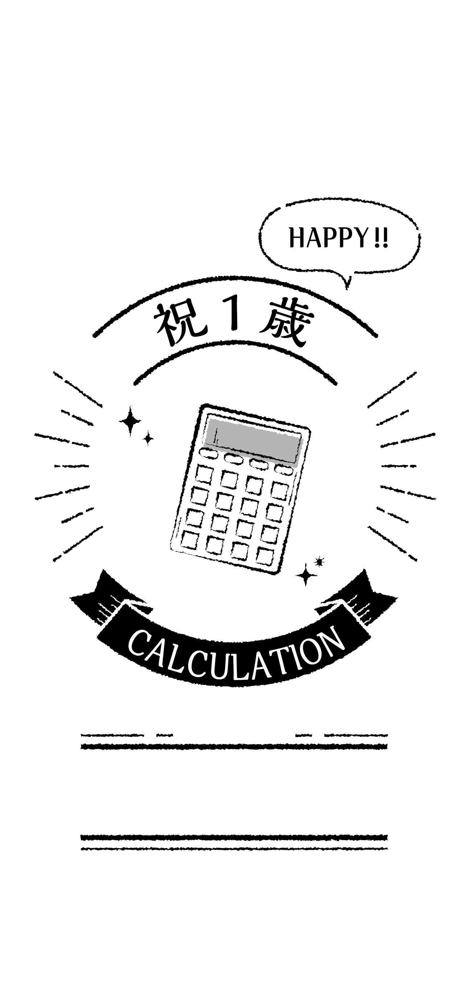

〇〇〇〇

〇〇

〇